WAAM Platform — Status Memo
PhotogrammetryWAAM-Blender-UX · Nathan Argetsinger · May 2026
A note regarding this doc … this static page is reflected by a hosted living doc that I will update as we progress over the next two months.
Scan for the live, continuously-updated status dashboard · https://waam-status.pages.dev/

Contents
Current Status
- Active threads in flight: Slicing · Weave & height feedback · Foxglove monitoring · Thermal (Lepton 3.5) · Shop health check · Natural Language MCP / ACP interfaces · Closed-loop control · Documentation
- Paused: Absolute-pose 3D-registered photogrammetry
30–60 Day Outlook
- Targets in flight: Timeline (Jun–Jul) · Theory / test prints · Showpiece prints & data packets · Public content · Public beta · Telegram notifications (via ACP) · Operator-ready UI
- Fundamental deliverables:
- Physical Prints + for each "the (digital) databag" (( {{INPUTS::input parameters, input STL}}, {{OUTPUTS::executed sliced GCODE, *.mcap ros2 bag recordings, high quality timelapse}} ))
- 3 "showpiece" prints at scale
- 3 "research" prints demonstrating a specific physical line of research inquiry (print interruption handling, thermal management)
- Youtube regularity — in service of the big one…
- Publish Beta Kernel no later than end of July
Annex
- Supplemental research threads: Seam gap & distance · Power-loss recovery · 3D-registered photogrammetry
──────────────────────────────

Current Status

Active Threads in Flight

Slicing (PrusaSlicer)
Geometry is sliced in PrusaSlicer in one of two possible modes:
- vase mode (continuous spiral, continuous increment z+)
- Layer by layer (each segment flat) — allows interweaving geometries
(( 3. Solid infill .. i haven't touched this much ))
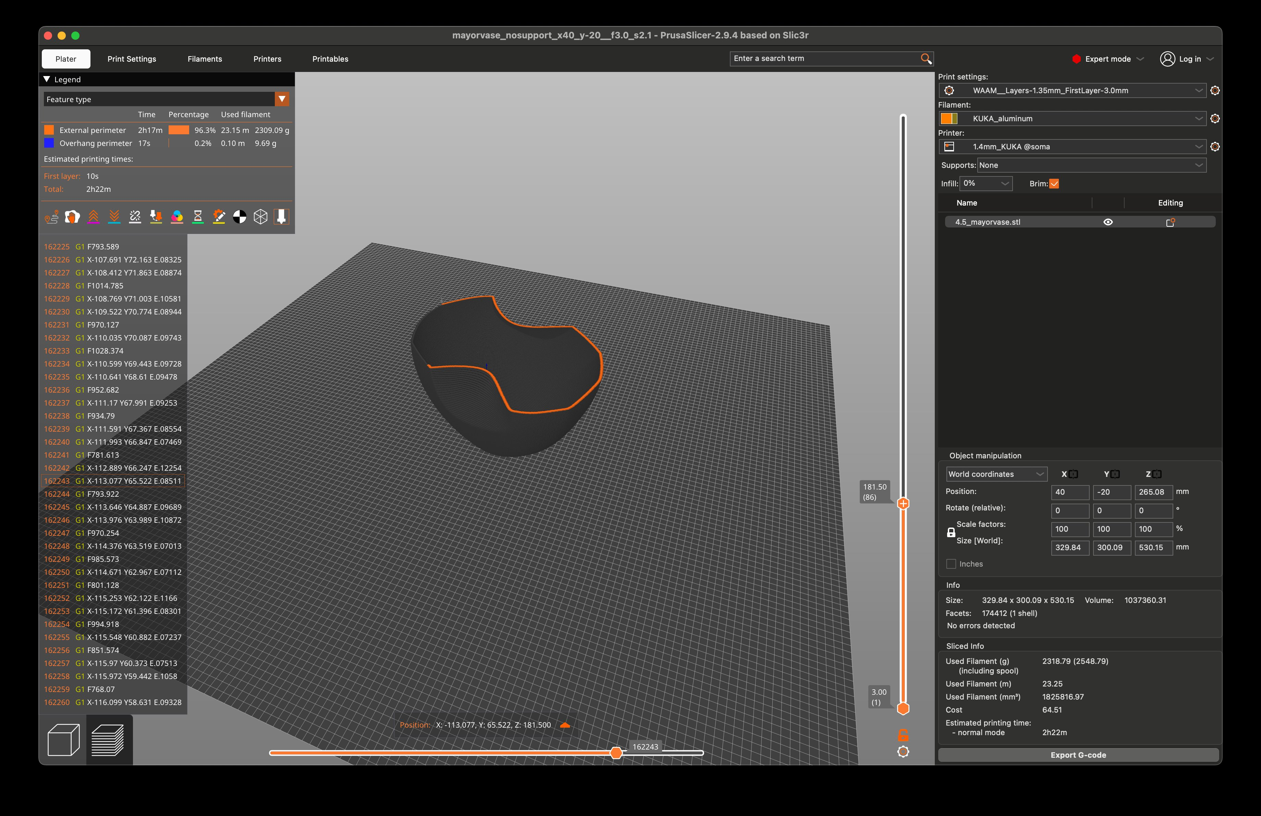
Figure 1. PrusaSlicer WAAM profile: single-perimeter vase wall and sliced g-code.

Preprocessing Prusa Output to welder params and [Weave & Height Feedback]
A post-process converts and massages raw E and F values. Later in pipeline superimposes a lateral weave (amplitude + wavelength) on the single-bead path to build wall width; deposited height is then reconstructed and compared against the commanded path to close the loop per layer. A visualization is created at this step.
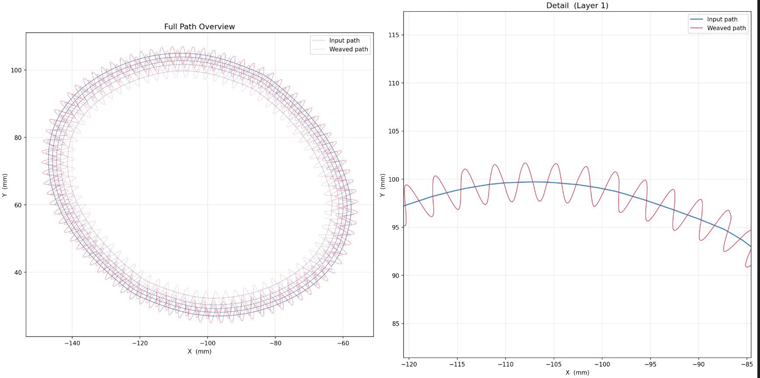
Figure 2. Weave modifier: commanded path (blue) vs. weaved path (red).

Post print visualization tooling and error metrics
Layer by layer viz of error in (x,y,z) space and RMS error per layer is a useful metric for how well the feedback controller is performing. Pictured below is a dead simple proportional controller only considering the prior layer (most naive approach possible).
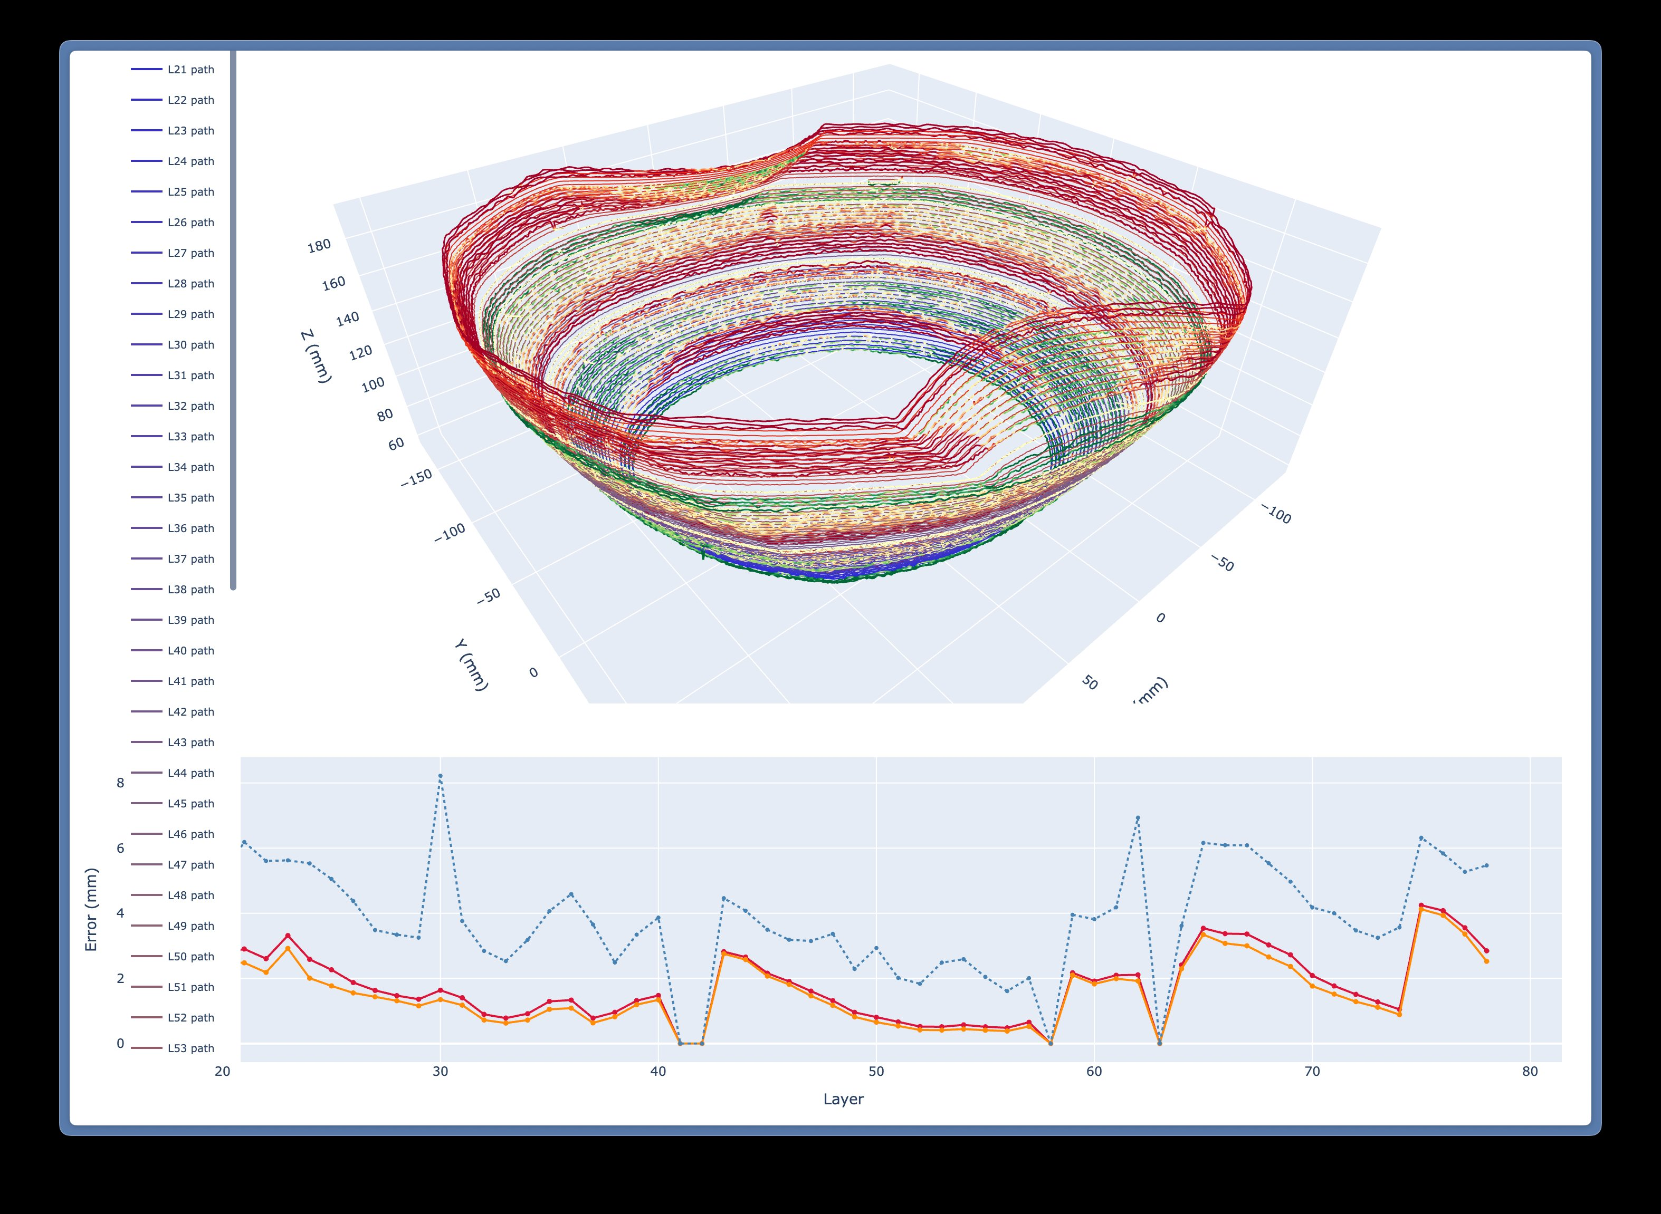
Figure 3. Reconstructed layer paths and per-layer surface error.
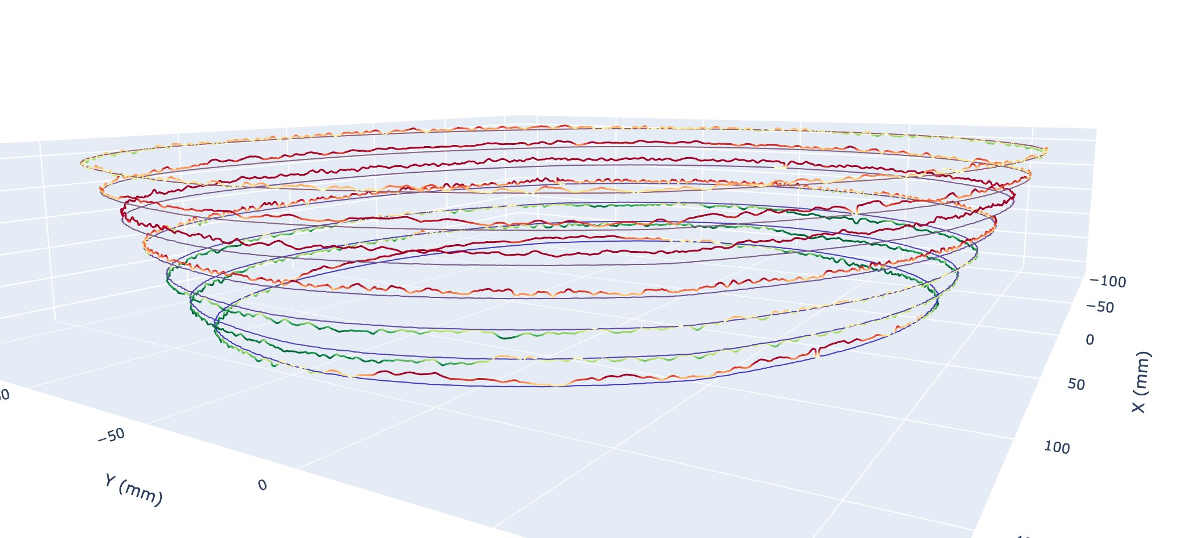
Figure 4. Stacked measured layer contours — level and concentricity over the build.

Foxglove Monitoring (ROS2)
Post print visualization tooling and error metrics (( REPLAY ))
A Foxglove layout over the ROS2 graph enumerates every sensor and the live process state — KUKA pose, surface error, and the process/thermal/TSO cameras — and replays the identical panels from recorded .mcap bags.
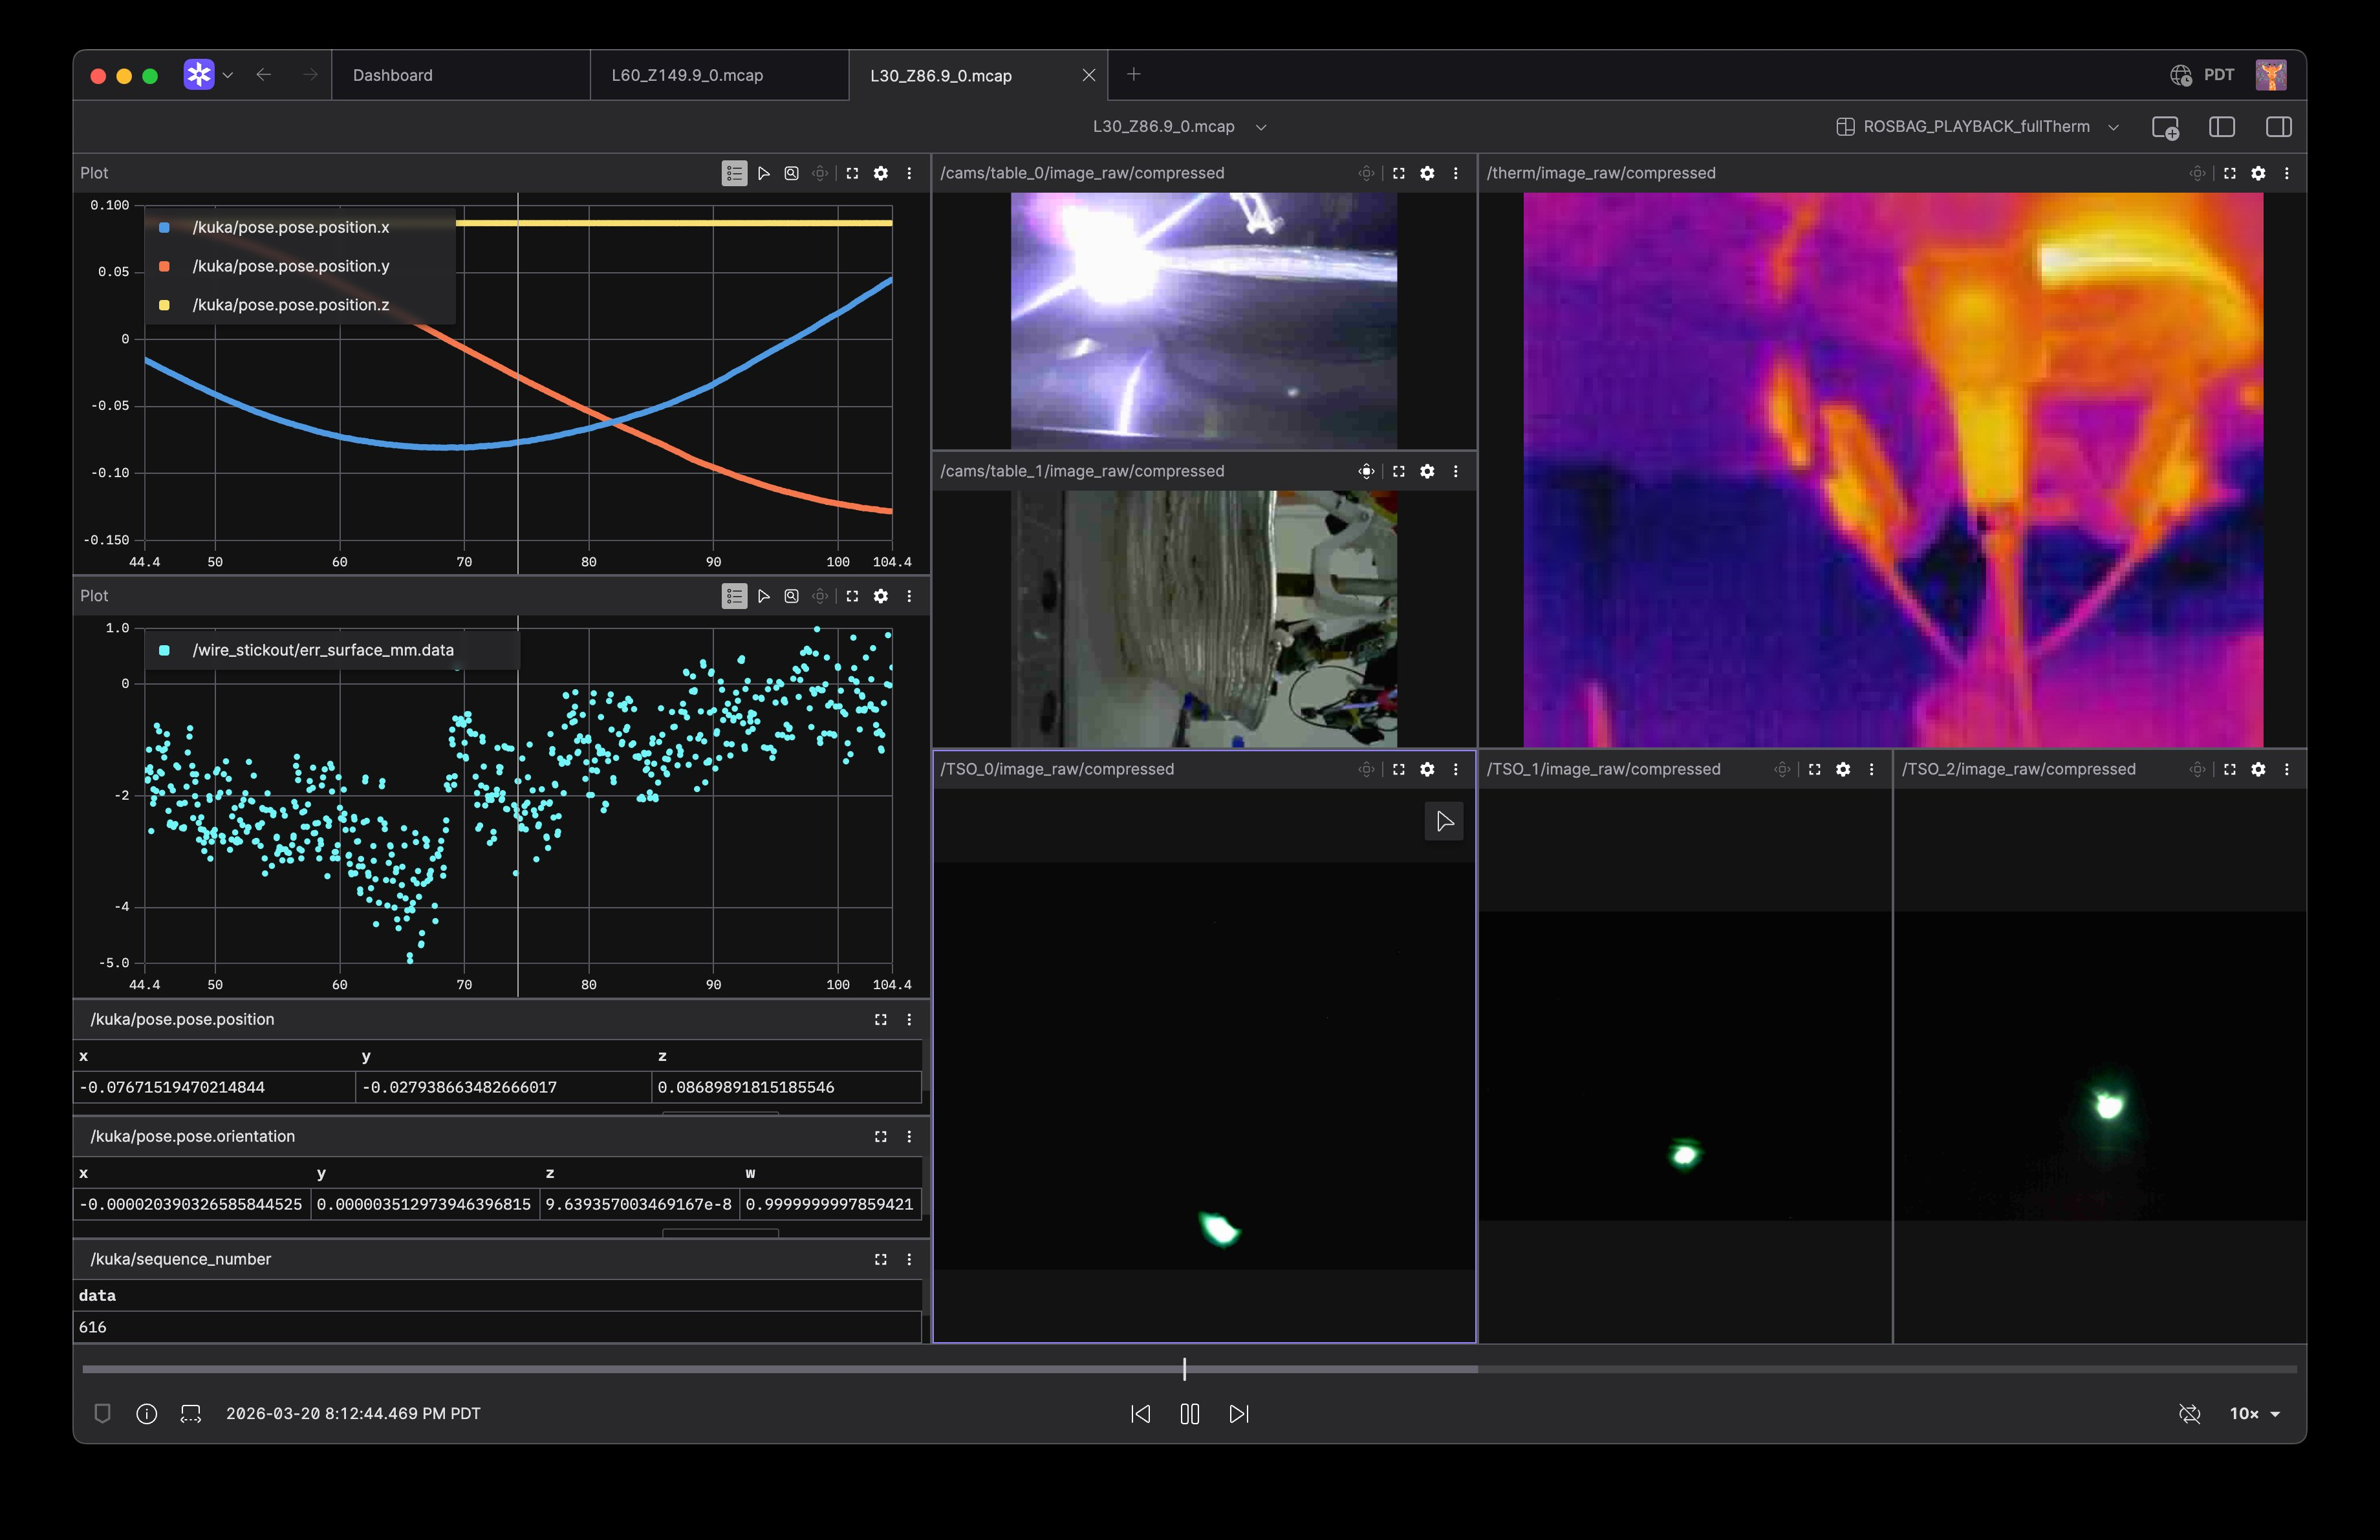
Figure 5. Foxglove layout: pose and surface-error plots, arc/thermal/TSO cameras, replaying an .mcap bag.
(( REALTIME MONITORING ))
The same foxglove tool is what I've been using to introspect the data on the graph. Along with a bit of natural language tooling thats just beginning to come through.

Thermal (Lepton 3.5)
A FLIR Lepton 3.5 in radiometric (TLinear) mode delivers absolute per-pixel temperature in Kelvin via GStreamer → ROS2, letting interpass timing gate on real substrate temperature rather than a fixed dwell (shown in the /therm panel of Figure 5).

Shop Health Check
There are many different pieces to the system. I've put some work into automating guaranteed good status so I can just come in and hit print (this has been a surprisingly major hurdle of sheer complexity).
A boot-time Shop Health dashboard checks per-host reachability and required components (camera streams/topics, DSLR capture, ROS 2 graph) against config/shop_inventory.yaml, rolling up to one auto-refreshing status; the capture below reads RED on two missing IMX708 topics and an unreachable M50 capture service.
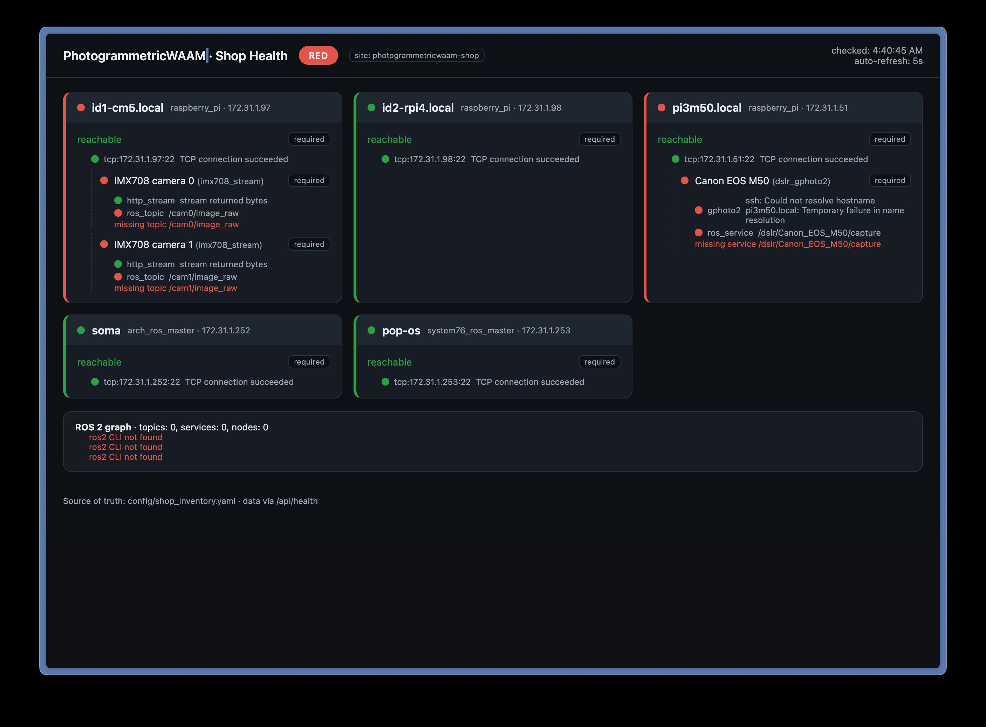
Figure 6. Shop Health dashboard: per-host reachability and required-component checks with overall rollup.

MCP / ACP Interfaces
An MCP server exposes high-level system status to a natural-language query interface (read/observe), while an ACP interface drives the agentic printing flow (operate/act); both are in development and couple to the web UI and headless interface.

Closed-Loop Control
Control modulates four factors from thermal and surface feedback: travel speed, wire-feed speed, weave amplitude/wavelength, and interpass wait. Seam position and gap are tuned as a separate research thread — see Annex → Seam Gap & Distance.

Documentation
System documentation is built as an Astro site and kept matched to the components it describes — keeping the docs in sync with the evolving stack is itself an active thread. Live at [ add docs URL ].

Paused — Absolute-Pose Photogrammetry
Temporarily paused — the single TSO angle has sufficed for simple prints. It remains the planned path to weld-gap/defect correction; detail in Annex → 3D-Registered Photogrammetry.

30–60 Day Outlook

Timeline (June–July)
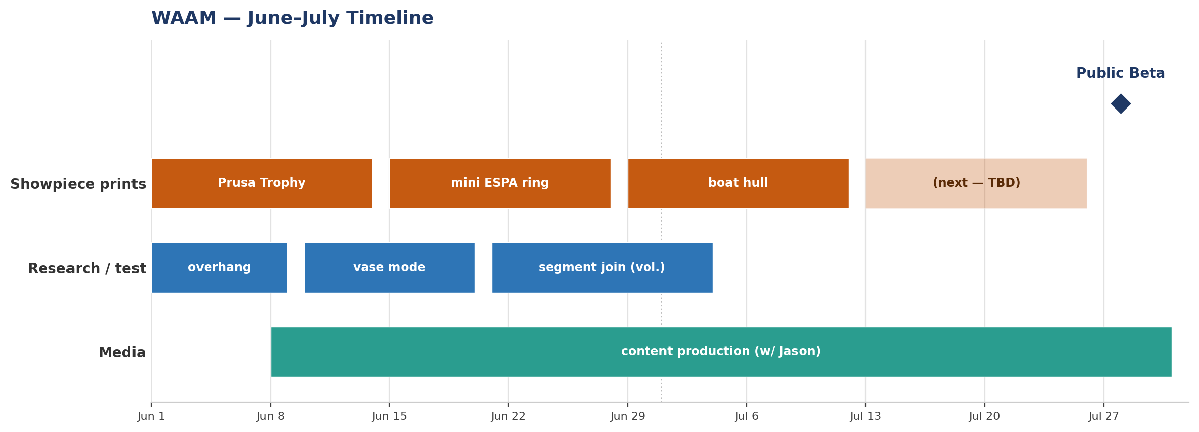
Figure 7. June–July timeline: showpiece print cadence, research/test prints, content production, and the Public Beta milestone. Print and research names are placeholders.

Targets in Flight
Every print — test or showpiece — yields a complete data packet: the PrusaSlicer WAAM g-code (STL → toolpath), its modulated weld and weave parameters, the end-to-end .mcap ROSBAG of the running system, a timelapse, and an accompanying health log resilient to sensor dropout and mid-print power-loss.

Theory / Test Prints
Small-scale parameter studies that precede the showpieces, each isolating one variable:
- Overhang
- Angle of attack — programmed tool orientation matching bead to bead normal
- Absolute thermal ceiling — a Lepton-measured temperature not to exceed
- Seam-gap calibration guarantees "flat" bead start/stop (also enables print interrupt) — the slicer-programmed seam gap distance [[link back to the seam demo earlier]]
- Proper PID control loop

Showpiece Prints (≤2-Week Cadence)
A new substantial showpiece on a two-week-maximum cadence, each delivered as the full data packet above.

Public Content
Short-form YouTube built directly off each captured print to document and promote the tooling ahead of launch, with production delegated in sync with Jason.

Public Beta
The headline target: public beta release within 30–60 days, fed by the print cadence and the content stream.

ACP Notifications
Break out ACP key results (completion, fault, calibration) to a single dedicated WAAM channel on Telegram/Slack/Discord, with global notifications off and a per-channel override so only WAAM pushes to the phone.

Operator-Ready UI
The web UI is maturing toward operator-ready — the ultimate goal is that a non-technical operator (Miguel, Matthew, or Frey) can set up, run, and monitor a print end to end without touching ROS, g-code, or the command line.

Annex

Supplemental Research Threads
Standalone working documents referenced by this memo.

Seam Gap & Distance
The layer start/stop — the seam — is tuned at the slicer: seam position Random and seam gap distance 18%, so start/stops are distributed around the wall and the per-layer overlap neither piles up nor opens a void. The bead crossover is dialed in against the Blender visualization and verified on the printed vessel rim.
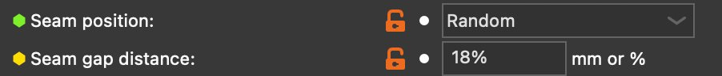
Figure 8. Slicer seam settings: position Random, gap 18%.
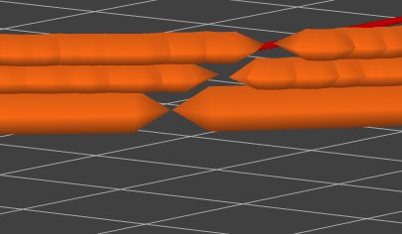
Figure 9. Bead crossover at the seam (Blender), used to tune the gap.
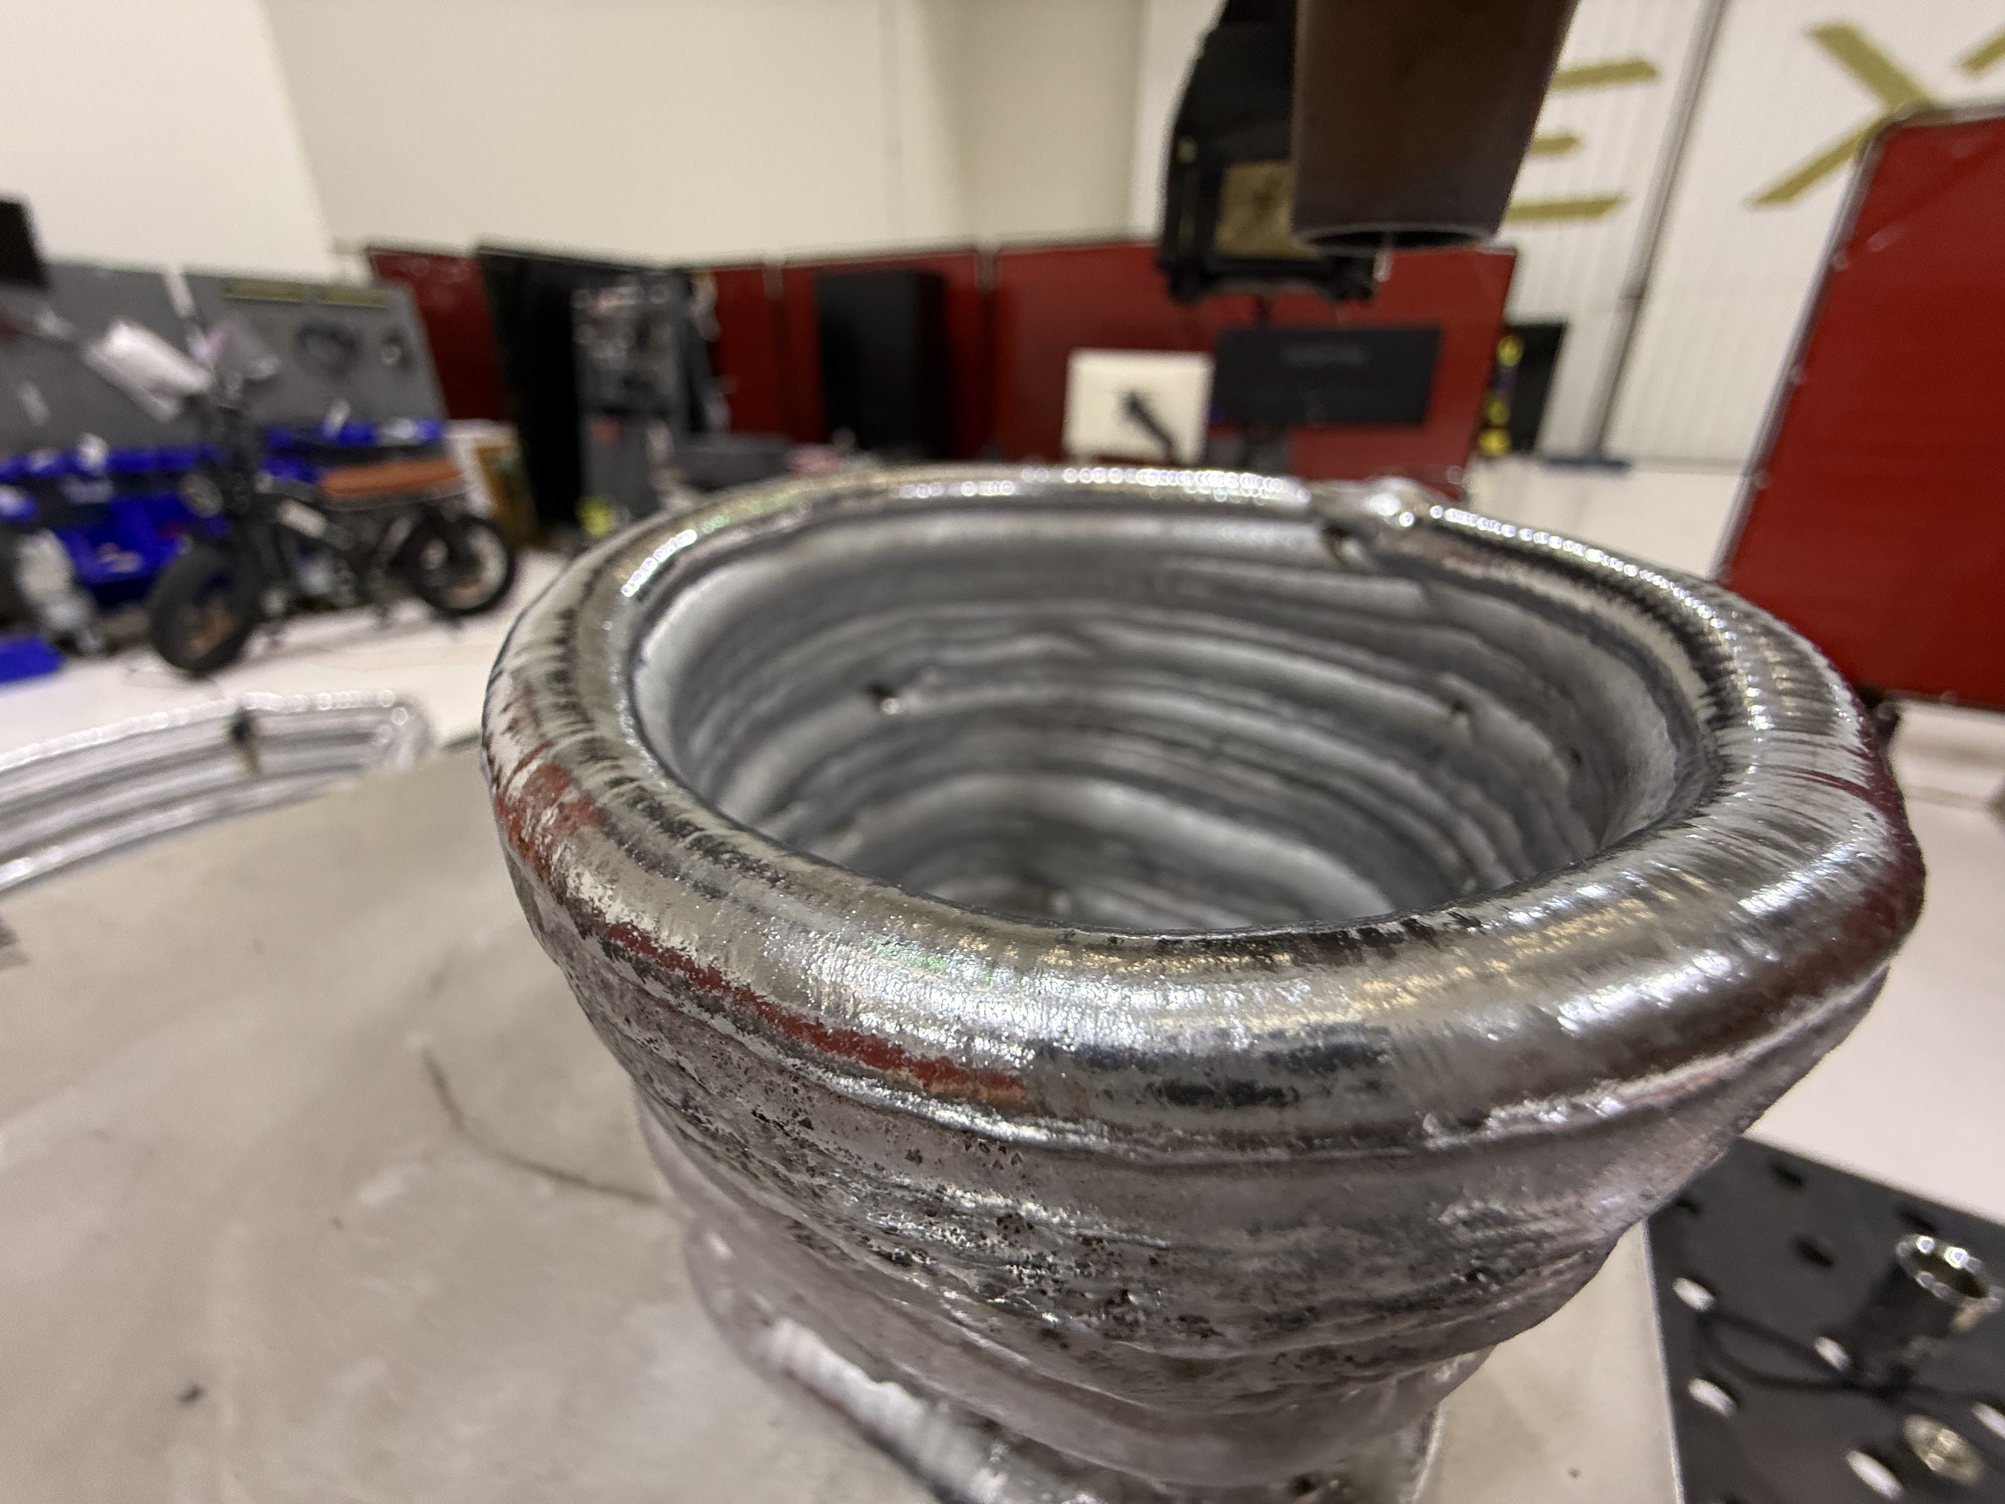
Figure 10. Printed vessel rim — the thicker loop bead where the seam start/stops, the physical result of the seam-gap tuning.

Power-Loss Recovery
How the cell recovers when the whole system powers down mid-print; began as an early troubleshooting ("panic") session and is carried here as a supplemental reference for dropout and power-loss resilience.

3D-Registered Photogrammetry
Finishing the absolute-pose, 3D-registered photogrammetry scans — near-integrated several months ago, since back-burnered — essential for correcting build flaws (e.g. bead-continuity / weld-gap defects) in situ, before subsequent layers bury them.
This was a complicated piece to figure out, and though I've benched it for the last two months or so it's actually quite close to integrated.. and it will be necessary for more complex prints.
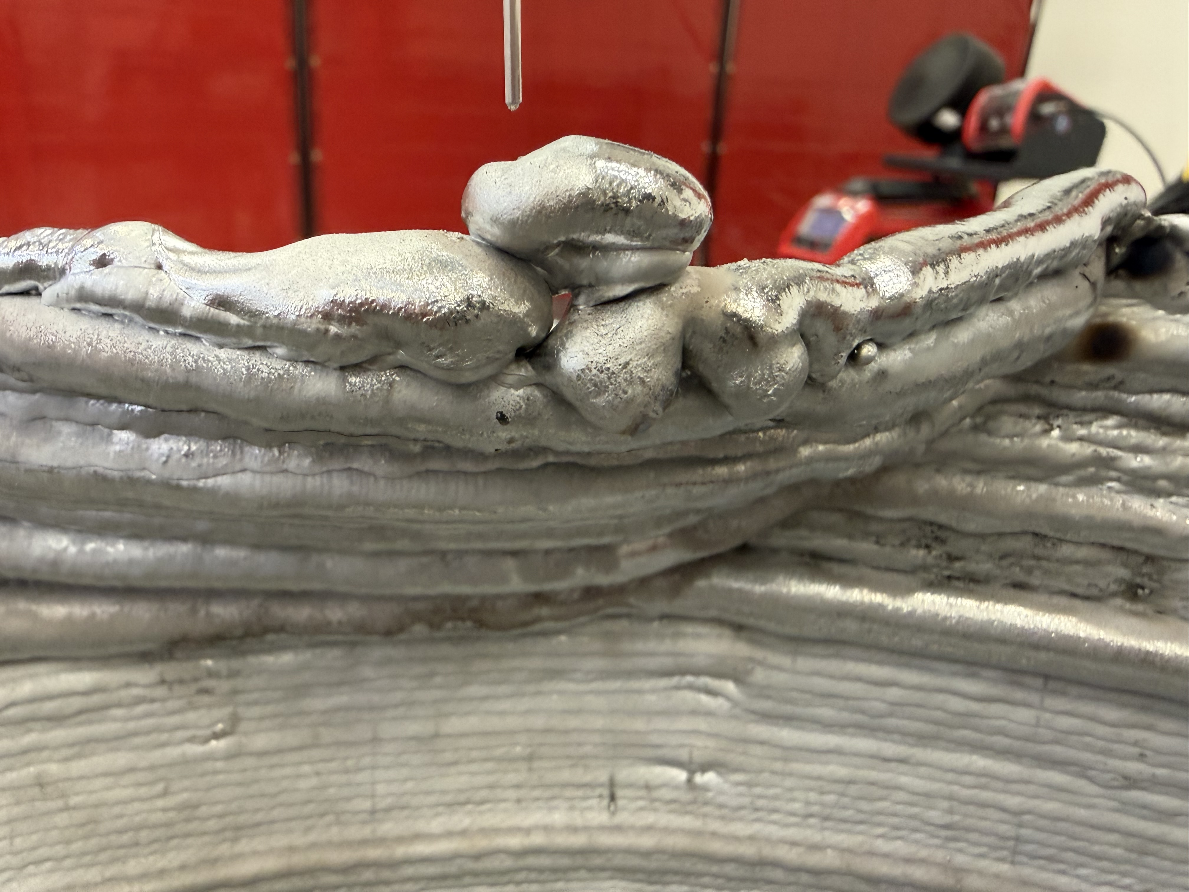
Figure 11. A deposition fault — piled / over-accumulated beads and a wall discontinuity — the class of defect 3D-registered photogrammetry is meant to detect and correct.
──────────────────────────────
Live status dashboard

https://waam-status.pages.dev/#pdf-v1_3
WAAM Status Memo · v1.3

